Seed Propagation for Lavandula

The Drawbacks

There are three primary reasons I do not propagate from seed:
- The resulting plants will vary from the source plant.
- Difficult to germinate without specialty equipment and chemicals.
- The effort is beyond my patience!
Additional drawbacks include:
- Limited seed availability.
- Seed is being mislabeled as named cultivars such as Lavandula angustifolia 'Hidcote' or 'Munstead' when the resulting plants will have variations and therefore are not true to the original plant.
Given these challenges, propagating lavender from seed does not meet my goal to provide systems with the highest probability of success for the student.

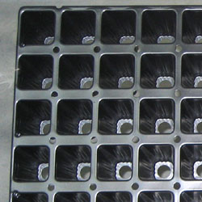
All of that said, I decided to provide this additional information for those who may be interested in plant variety development where the cross-pollination and therefore seed propagation is necessary.
Starting from seed may also be the most efficient and least expensive way to produce a quantity of plants for oil production when it's the species you want, not necessarily the individual plant characteristics.
The following information is from coursework I had in plant propagation at a local community college. It is supplemented with information from personal experience, interviews with growers as well as Internet research.

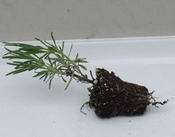

The Process

- Use a sterile seed-starting mix in a plug tray with bottom heat available.
- Higher germination rates occur if the seed is fresh.
- According to Michael A. Dirr in The Reference Manual of Woody Plant Propagation no pretreatment is necessary before sowing Lavandula angustifolia seed. It has been reported though that seeds soaked in 200ppm GA₃ (Gibberellic acid) and kept at 50˚ to 68˚F for 16 hours and 86˚F for 8 hours germinated greater than 90%.

- Seeds benefit from light while germinating so only cover lightly when sowing. (You may be interested in Temperature and Light Effects on Germination of Lavandula stoechas Seeds)
- Germination occurs around 70ºF to 75ºF and will take two or more weeks.
- Once germination occurs, allow one to three months for root and top growth to develop before transplanting into 3" to 4" pots.
- Adding fertilizer to the sterile seed-starting mix in the tray can help jump-start the plants. However, caution should be taken since it can invite fungus in cool, humid situations.
- Once transplanted, when the seedlings are approximately 3 inches tall, allow another three months or more before transplanting into a larger pot or into the garden.
- Be sure to use your Plant Propagation Record to keep track of your process. As you experiment, your records will help you avoid failure and duplicate success.

Are you still with me? I do not actively propagate lavender from seed for reasons already noted. I have potted up several un-named volunteers from several cultivars of L. angustifolias in my garden. None resemble the parents, but they provided a few fragrant cups of lavender tea and a few sweet sachets.

The Resources
Dirr, Michael A., and Charles W. Heuser, Jr. The Reference Manual of Woody Plant Propagation. Athens, Georgia: Varsity Press, Inc., 1987.
Hartmann, Hudson T., et al. Plant Propagation: Principles and Practices. 6th ed. Upper Saddle River, New Jersey: Prentice Hall, 1997
Upson, Tim, and Susyn Andrews. The Genus Lavandula. Portland, Oregon: Timber Press, 2004.

